A MINI PROJECT REPORT

**On**

**RESTAURANT MANAGEMENT**

**SYSTEM**

**Submitted by**

***VARUN AGRAWAL (171500376)***

***BHARAT JOHRI (171500083)***

***VIVEK AGARWAL (171500392*)**

**TO**

**DR. ANAND PARKASH GUPTA**

Department of Computer Engineering & Applications

**Institute Engineering & Technology**

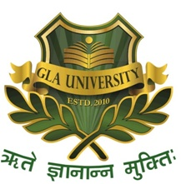

**GLA University**

**Mathura- 281406, INDIA**

**2019**

**Department of computer Engineering and Applications**

**GLA University, Mathura**

**17 km. Stone NH#2, Mathura-Delhi Road, P.O. – Chaumuha,**

**Mathura – 281406**



**Declaration**

We Students of B.tech (CSE) 5th Semester at GLA UNIVERSITY,MATHURA is going to submit Website on “ Restaurant Management System ” .This is our own work and has not been submitted earlier to university or to any other institute for fulfillment of requirement of a course of study.

**Name of Signature with Candidate**

VIVEK AGARWAL

VARUN AGARWAL

BHARAT JOHRI

**Department of computer Engineering and Applications**

**GLA University, Mathura**

**17 km. Stone NH#2, Mathura-Delhi Road, P.O. – Chaumuha,**

**Mathura – 281406**



**CERTIFICATE**

This is to certify that the project entitled “**Restaurant Management System”** carried out in Mini Project Lab is a bonafide work done by

**BHARAT JOHRI (171500083), VARUN AGRAWAL (171500376), VIVEK AGARWAL (171500392)**

**Signature of Supervisor :**

**Name of Supervisor :**

**Date :**

1. INTRODUCTION

**1.1 Objective**

The main objective of this 4 week project is to develop a client/server model, which deals with “Online Restaurant Meal Reservation System”. The system has two parts first for the customers and the other for the management side.

The customer side allows the customer to view menu list according to the time of delivery he desires and reserve meal for that specific time, and at the management side the staff is allowed to edit information regarding menu list, price, assigning cook, etc.

**1.2 Scope - RESTAURANT MANAGEMENT SYSTEM PROJECT**

We are greatly constrained by “Time limitations” as only 4 weeks are given to complete the project. So we limited our scope of project to “Meal Reservation” only.

The sole purpose of the project is to learn the web application development, how databases works for the web application and how to co-ordinate with databases to produce more commercial web applications for daily business.

We will try our best to make better usage of HTML, CSS, JAVASCRIPT, MYSQL, PHP and surely all in a better team work.

**1.3 Hardware/Software Interface:**

This section lists the minimum hardware and software requirements needed to run the system efficiently.

**Hardware Interface:**

• i5 Processor

• 450 MB of free hard-drive space

• 4 GB of RAM

**Software Interface:**

• Operating System: Windows 8/10

• Web Browser: Google Chrome

***METHODOLOGY***

ER Diagram of customer interaction

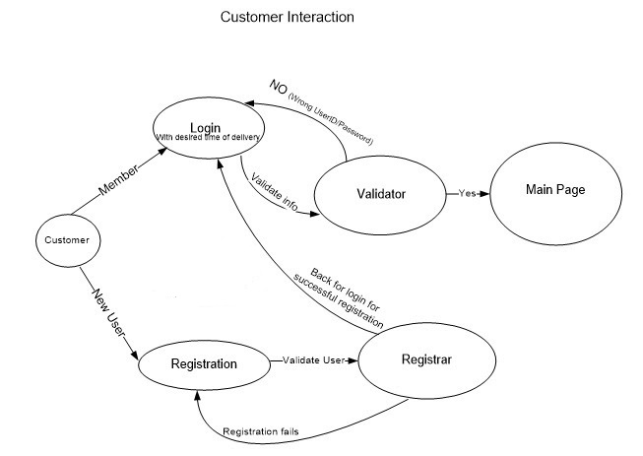

ER Diagram of Restaurant Management System

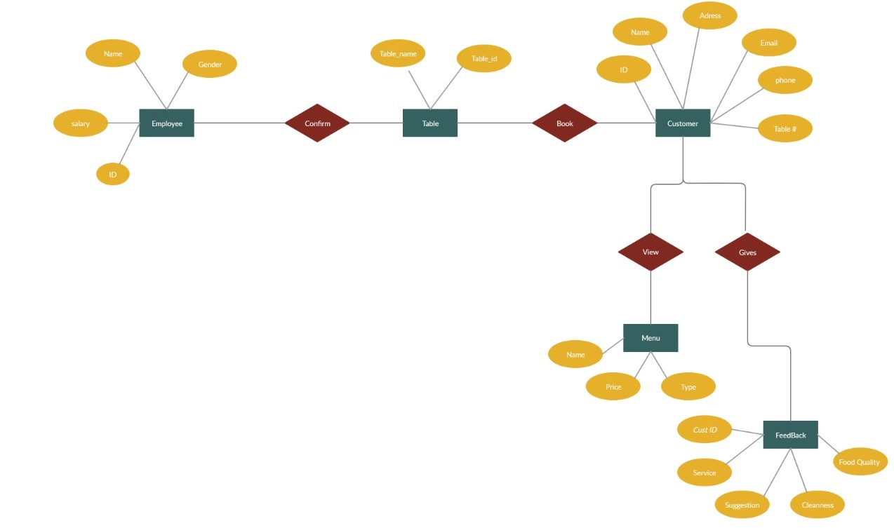

***IMPLEMENTATION***

***STEP 1: HOME PAGE***

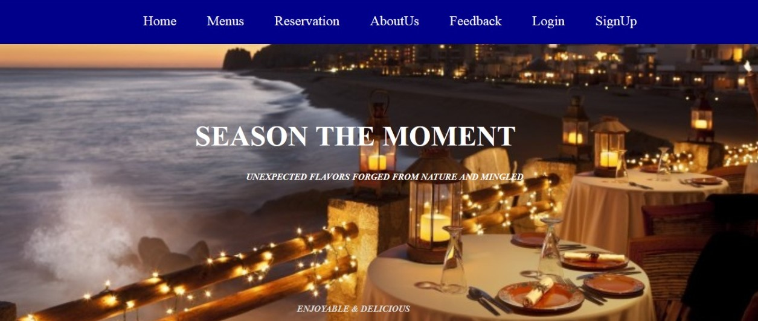

***AFTER LOGIN*** 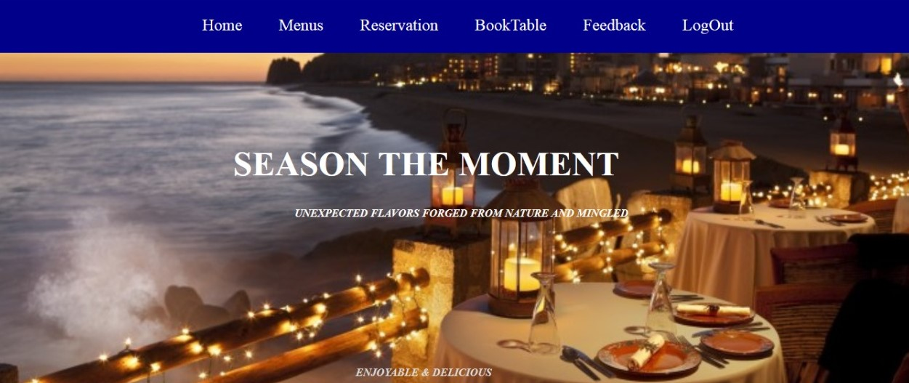

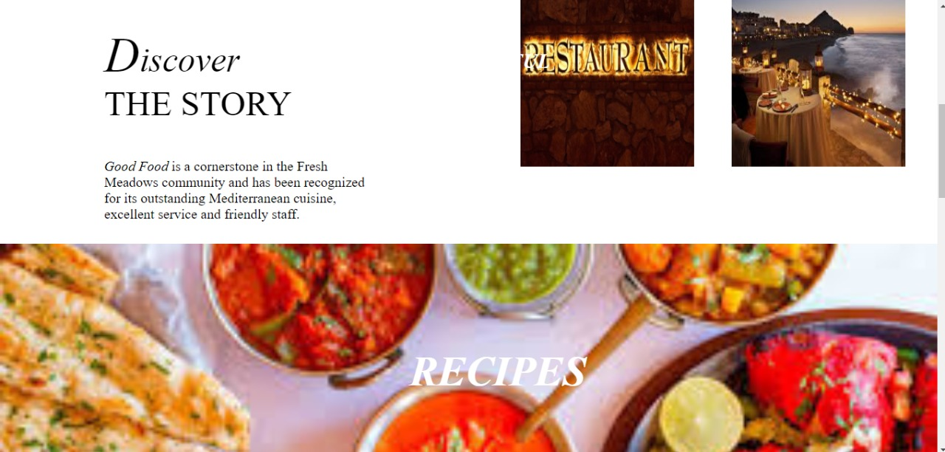

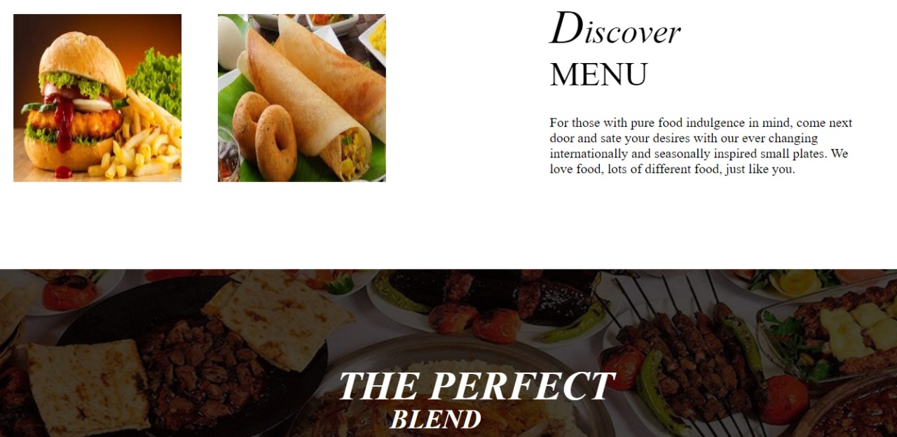

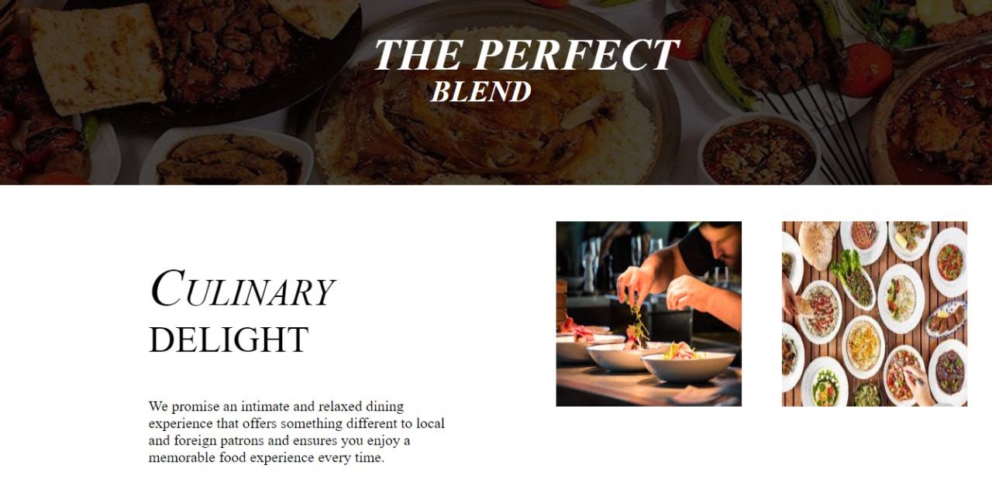

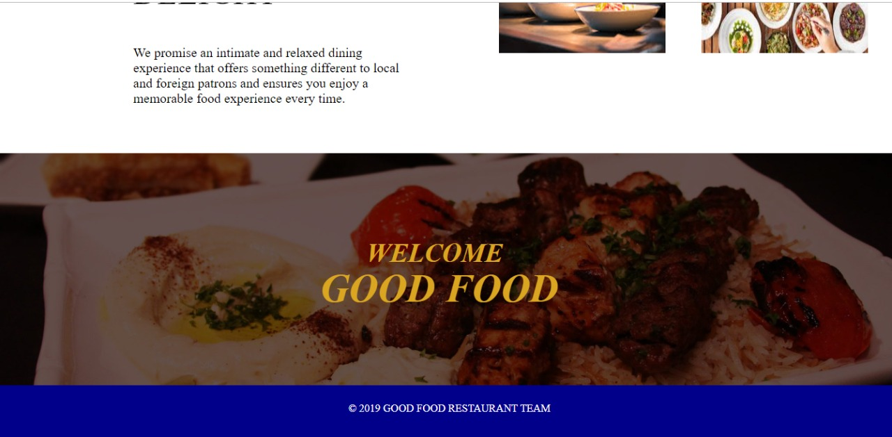

***STEP 2 : MENU PAGE***

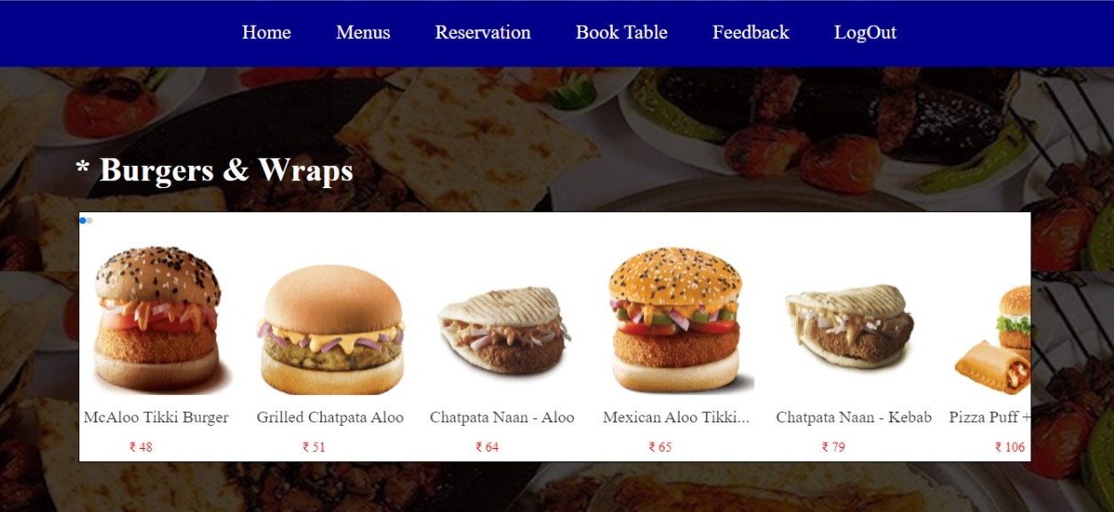

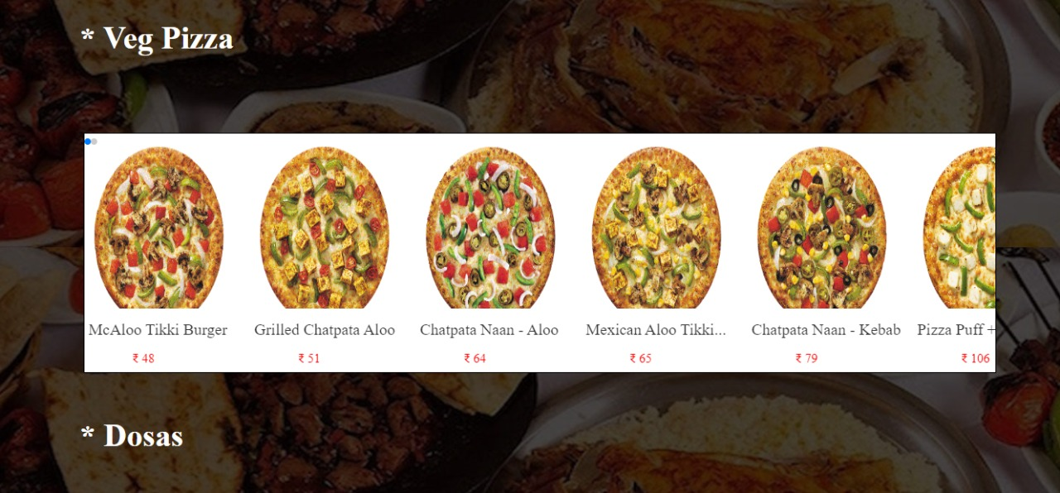

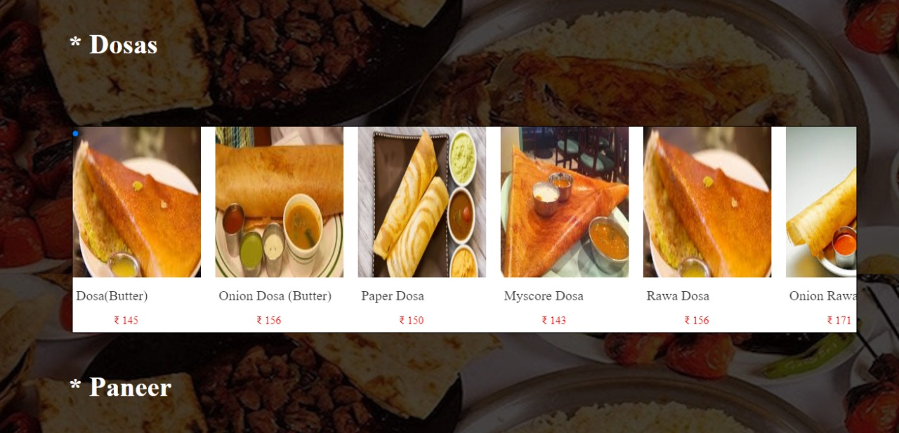

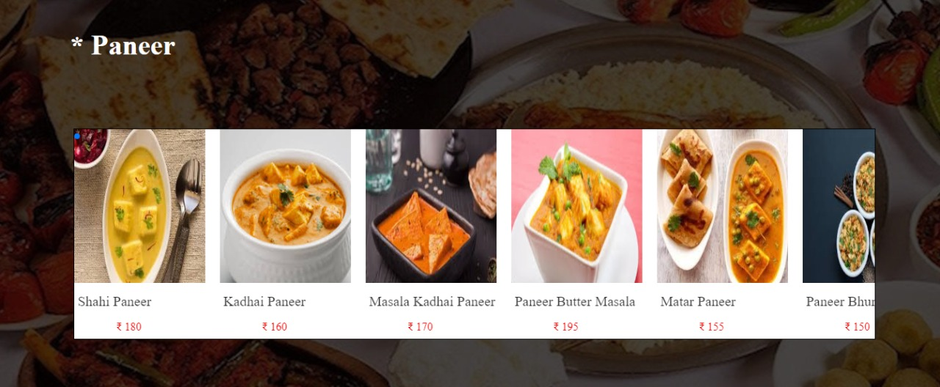

***STEP 3 : RESERVATION PAGE***

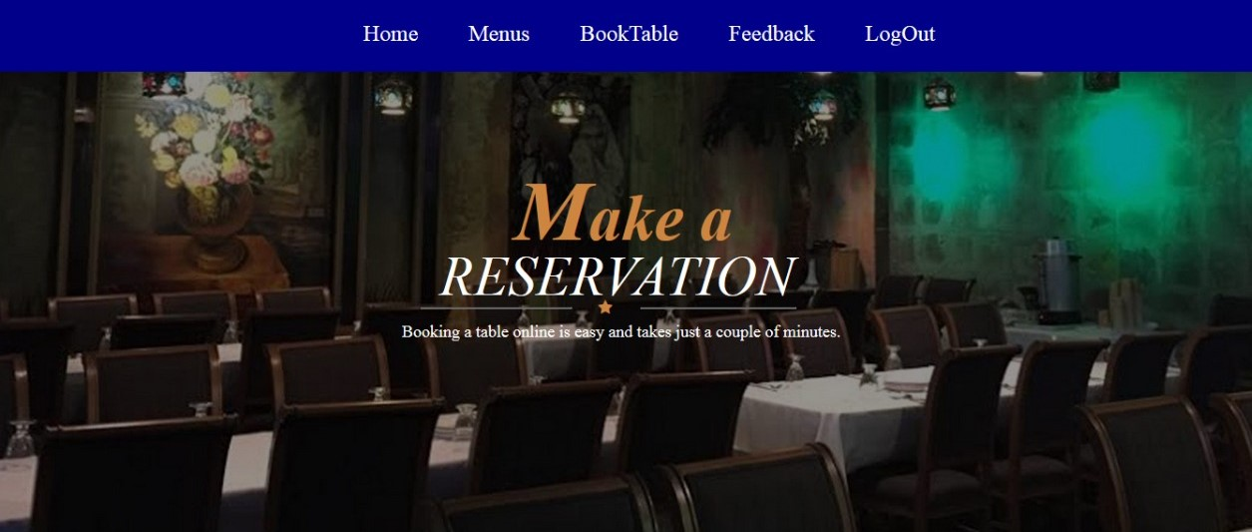

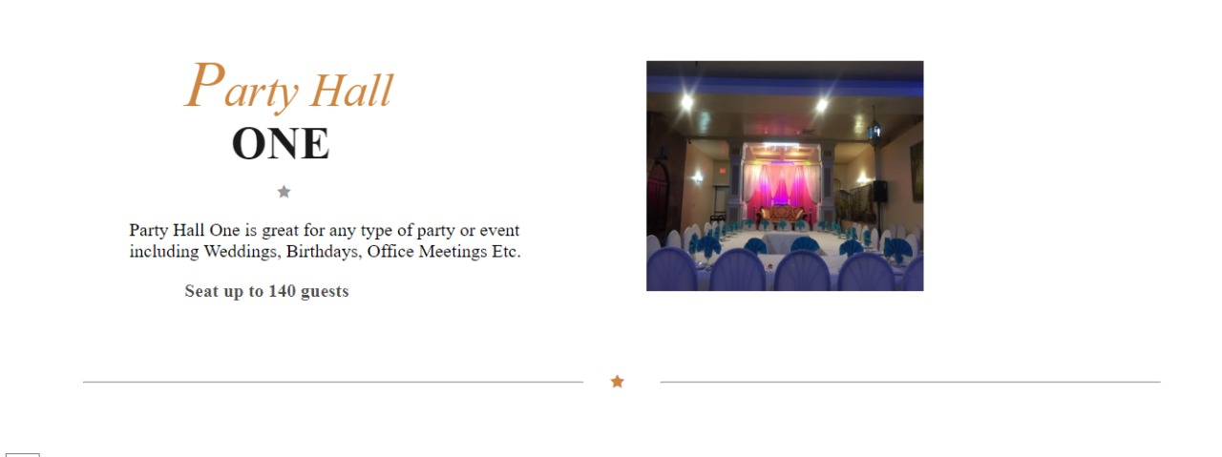

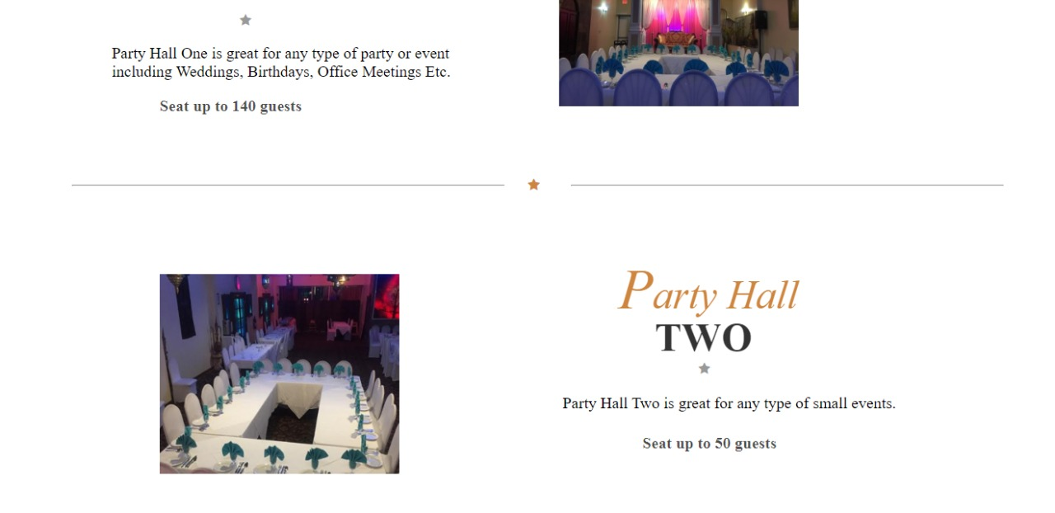

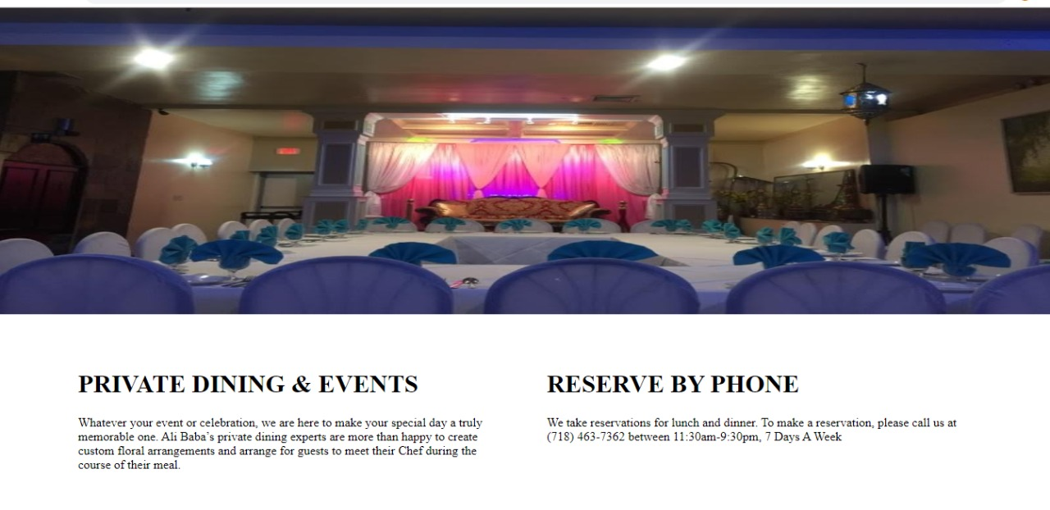

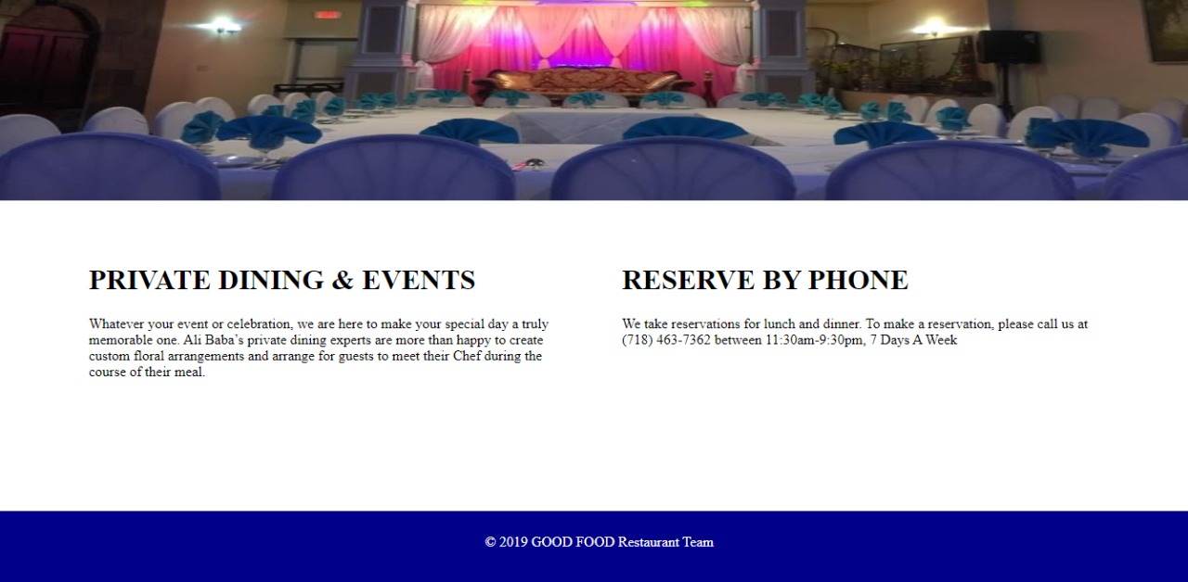

***CODE :***

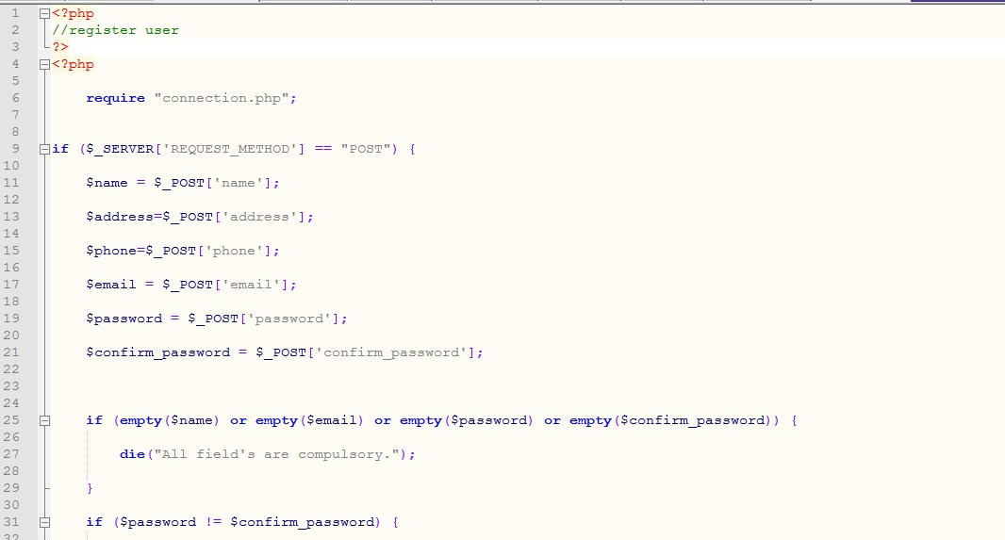

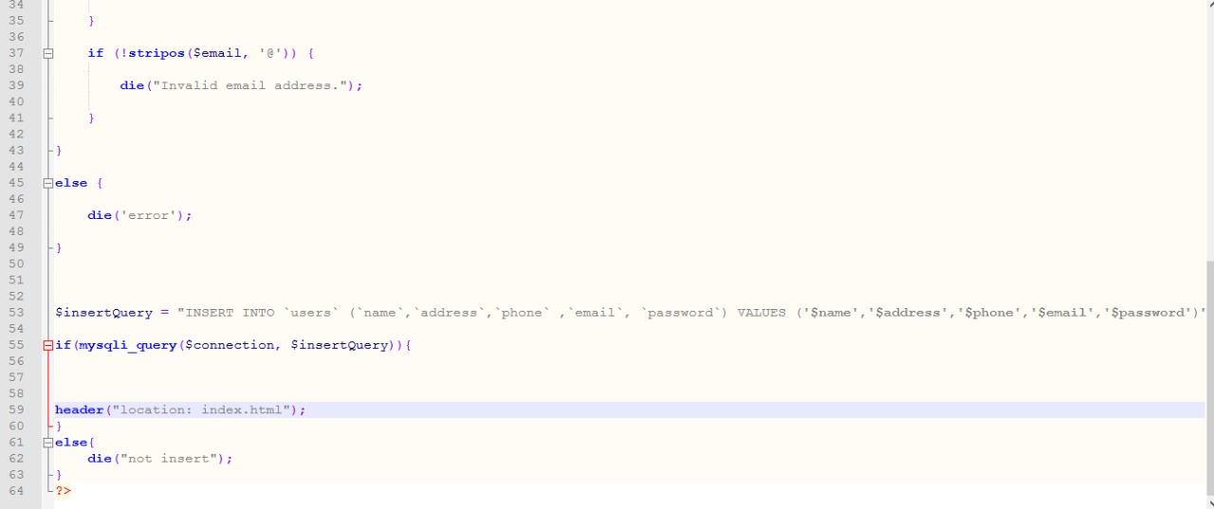

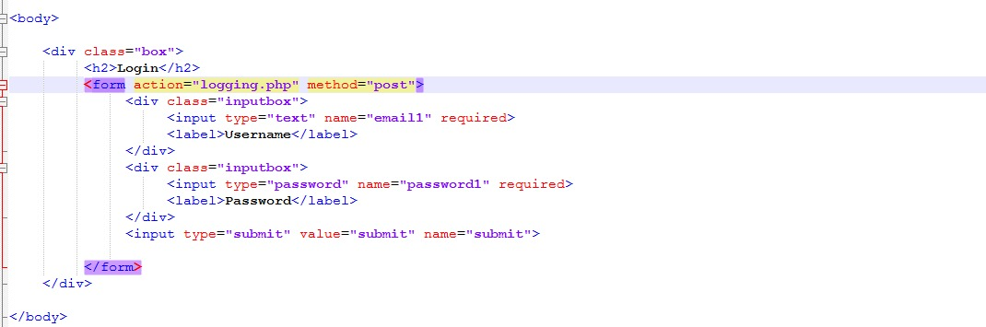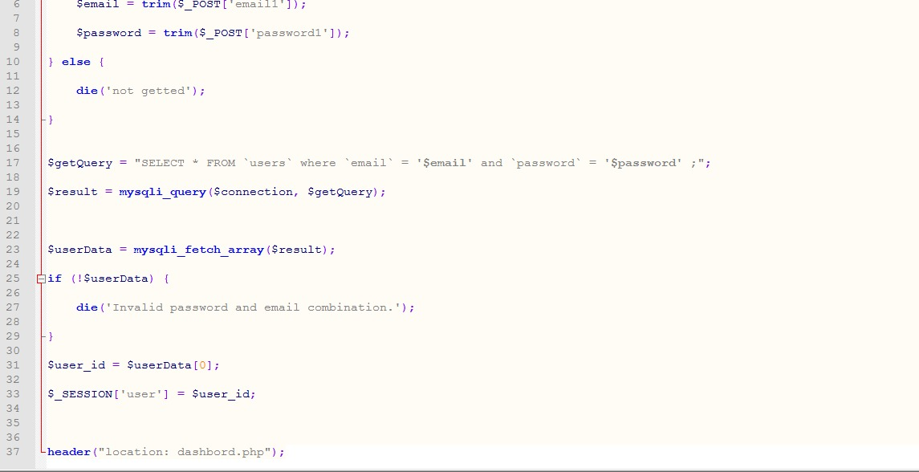

**CONTRIBUTION SUMMARY**

BHARAT JOHRI (Front-End Work)

VARUN AGRAWAL (Front-End Work)

VIVEK AGARWAL(Back-End Work)

**EXISTING FEATURES:**

* Login Page
* Signup Page
* Home Page
* Menu Page
* Reservation Page
* Logout page

**REMAINING FEATURES:**

* Feedback
* Table Booking
* Hall Booking
* Contact Us

**REFERENCES**

[https://www.w3schools.com](https://www.w3schools.com/)

<https://www.udemy.com>

<https://www.youtube.com>